**LITERATURE SURVEY**

One of the most challenging tasks in the education sector in India is to predict student's academic performance due to a huge volume of student data. In the Indian context, we don't have any existing system by which analyzing and monitoring can be done to check the progress and performance of the student mostly in Higher education system. Every institution has their own criteria for analyzing the performance of the students. The reason for this happing is due to the lack of study on existing prediction techniques and hence to find the best prediction methodology for predicting the student academics progress and performance. Another important reason is the lack in investigating the suitable factors which affect the academic performance and achievement of the student in particular course. So to deeply understand the problem, a detail literature survey on predicting student’s performance using data mining techniques is proposed. The main objective of this article is to provide a great knowledge and understanding of different data mining techniques which have been used to predict the student progress and performance and hence how these prediction techniques help to find the most important student attribute for prediction. Actually, we want to improve the performance of the student in academic by using best data mining techniques. At last, it could also provide some benefits for faculties, students, educators and management of the institution

Introduction In Indian education system checking student’s performance is a very essential in higher education. But we don’t have any fixed criteria to evaluate the student performance. Some institutions student performance can be Performance Prediction in Education using Data Mining Techniques 41 observed by using internal assessment and co-curriculum. In the Indian context, an institution with the higher degree of reputation using the good academic record as its basic criteria for their admissions [1]. There are lots of definitions of student academic performance prediction should be given in the literature. Different authors are using different student factors/attributes for analyzing student performance. Most of the author used CGPA, Internal assessment, External assessment, Examination final score and extra co-circular activities of the student as prediction criteria. Most of the Indian institution and universities using final examination grade of the student as the student academic performance criteria. The final grades of any student depend on different attributes like internal assessment, external assessment, laboratory file work and viva-voce, sessional test. The performance of the student depends upon how many grades a student score in the final examination. Norlida Buniyamin, Pauziah Mohd Arsad et al. (2013) stated that what are the significance of academic analytics for an educational institution and how they work for the improvement of education. They also proposed an intelligent recommendation intervention system to improve the student’s performance and achievement in education. This system uses two different student attribute to measure the achievement and that is student grade and student information [2]. Zaidah Ibrahim and Daliela Rusli et al. (2007) stated that predicting student's performance is very critical for any educational institution because it is important for the formation of new rule and standards for the improvement of the education and reputation. They used CGPA and demographic attributes of the first year student to predict their result in the first year of education in engineering [3]. Data mining techniques which are used in mostly education are known as Educational data mining. There are lots of data mining techniques are available to predict the student performance. Education data mining help to find the hidden information from a huge database of education setting, because at present lots of data are generated in educational institution related to student [4]. Further, this hidden information can be used for performance, dropout and final result prediction of the student. It also helps the educator, management and faculties to work according to the learning standards of the students. Actually data mining help in the different field of education sector [5]. So to properly understand the real meaning of the data mining in education we need to do a systematic literature review on different work done by the different researcher. Our main objectives to this proposed work are: i. To understand, analyse and then find the difference between different prediction techniques of data mining in education. ii. To identify and understand different student attributes which are mainly used for the predicting the student performance. iii. To identify and understand the different prediction techniques which are mainly used for predicting the student performance. The above points are the main focus of our study. In section 2, the main focus will be given on the methodology adopted for the formation of research questions for this paper and literature survey. In section 3-4, the main focus of the study is to find or identify the important factors on Predicting Student's performance and prediction methods used for student performance. In section 5-6, the main focus is one the overall discussion on the result of the study and in the last conclusion and future work scope is given.

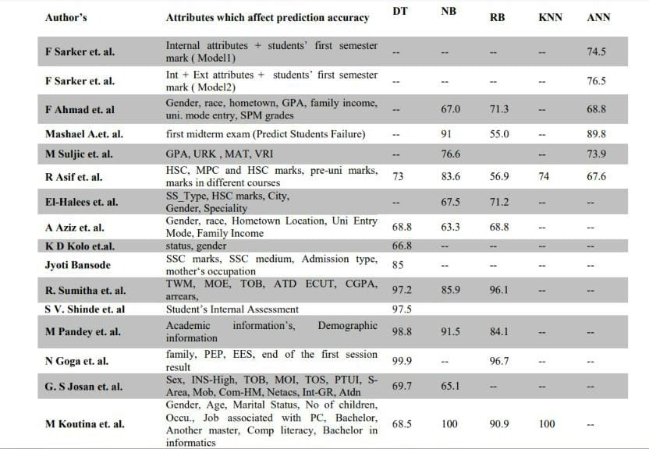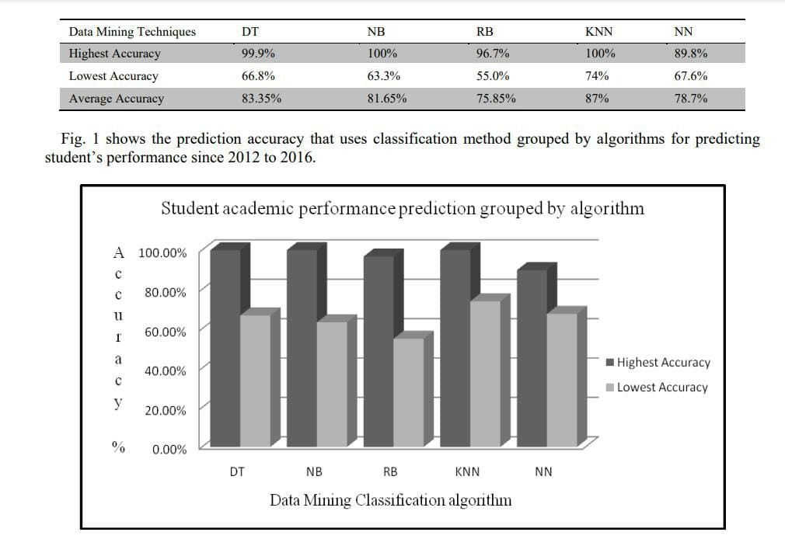

Acknowledgements I am grateful to my guide Prof. A.J. Singh and Dr Disha Handa for all help and valuable suggestion provided by them during the study.

**References**

[1] Mihai Dascalu and Elvira Popescu et. al., Predicting Academic Performance Based on Students’ Blog and Microblog Posts, Springer International Publishing Switzerland 2016 K. Verbert et al. (Eds.): ECTEL 2016, LNCS 9891, pp. 370–376, 2016. DOI: 10.1007/978-3-319-45153-4_29. [2] U. bin Mat, N. Buniyamin, P. M. Arsad, R. Kassim, An overview of using academic analytics to predict and improve students’ achievement: A proposed proactive intelligent intervention, in: Engineering Education (ICEED), 2013 IEEE 5th Conference on, IEEE, 2013, pp. 126–130. [3] Randa Kh. Hemaid and Alaa M. El-Halees, Improving Teacher Performance using Data Mining, International Journal of Advanced Research in Computer and Communication Engineering